Mainsail Menu Bar

**Ketch Rigged Layout**

Main Sail Layout: Auto Reefing Sails {collapse@device}

Main Mast: Burgee Height [:::] Hamburger Icon Scale: 20 X 20 Pixel

Main Site Navigation Masthead {<[{2x*x3}]/>}

Mizzen Mast: {[{Product Icon / Name}]}

About Splash

Container 2: Responsive Behavior (Progressive Collapse)

Index 1: Big Picture

Architecture  
Technology  
Taxonomy  
Look & Feel

Index 2: Projects

Recent Projects  
Project Types  
View All Projects  
New Project

Index 3: Tools

W2 Studio (Genesis Design Tools)  
- (Web based IDE)  
- (Smart WYSIWYG)

Add Taxonomy Documentation

Project Management

Business Analysis

Container 3: Responsive Behavior

Index 1: Help

Help Documentation

Index 2: Settings

Role > PM / BA / WD / ENG / FS

Index 3: User

Genesis User Preferences

DRX User Preferences [Insert Brain Gear In the gap below and in the video make this white area ruffle in the wind and blow full w/sound effects – Ask for Kenny’s help]

**Genesis CMS**

**A Sea Farer’s Guide to Web Design & Layout Principles**

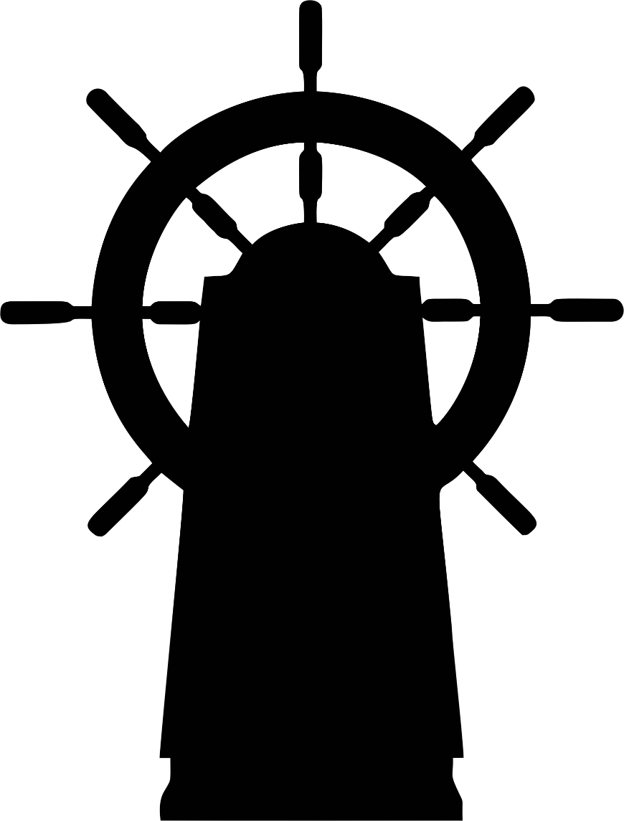

A DataRx Open Source Publication, CC / MIT 2018  
Author: Sean McNeill, Founder: DataRx.org

Charting a Course for Success



Table of Contents

* About Genesis CMS
  + Tales from the Sea… Origins & History, and traditions
  + Why does the industry need yet another CMS?
  + Key Principles & Concepts
  + Automation Framework
* Genesis CMS Integration Guides
  + Sass/Less Integration Maps
  + JavaScript Integration Maps
  + React Integration Maps
  + Angular Integration Maps
  + NodeJS Integration Maps
  + RStudio/Python Integration Maps
  + Sabino/Sabercat/Wildcat Integration Maps
  + W2UI Extended Integration Maps
  + Fit UI Extended Integration Maps
  + UI Framework Integration Maps
* Getting to Know the Rigging
  + A {?practical?/*scratch{*naughty/?naugtical,hmmm….  
    .?api.<help?>h? –H? %$#%^& [BANG BANG BANG] –H?  
    What the Hell yes this?  
    This is The Context Engine.  
     It is a Design Concept I am Working On  
     The concept is simply. How do I Design and Engineering a Documentation System   
     that translates Designer Ideas into Clearly Defined Engineering Requirements.   
      
     For more information and how you can help click here.
  + >A.Psuedo.Nautical.Yernacular.Guide().To.Understanding.API’s.
  + You all ready for this?  
    Turning.our.Thoughts.Into.(Emojies.and[Our.Emojies.Into.Ideas()]));  
    {Into()}.To(BFF[]?Margie&cc[ThatBitchy.Kathy].not(!<nice-kathy>notify</nice-kathy>!));
  + Knot.Tying.101()
  + to?knot:bowline.true();

?What am I doing?

?Am I Quite?Context.[.design . Design Language API called Laugh out Loud]:

Designing a Documentation Easy to Learn, Documentation Machine.

machine

* Learning Old English
  + Learning to Design In OldEnglishy{}
    - Learning Calligraphy()
      * A Design’s API Into the World of Programming your ideas into Designs
* Charting Your Navigation Documentation

Shipping Containers

W2UI Extended Integration Guide

Other Navigation Controls (A Sail refers to a navigation component)

* Main Mast (Top Shelf Menu)
* Mizzen Mast (Second Top Shelf Menu)
* Whisker Pole Configuration
* Mainsail Component
* Spinnaker Sail Component (Not to be confused with the Spinnaker C.I. platform)
* Genoa Sail Component
* Jib Sail Component

Understanding The Rigging

Learning the ropes

**Anatomy of a Page Layout Panel >** Whisker Pole Configuration

|  |  |  |
| --- | --- | --- |
| TOP | | |
| LEFT | MAIN   |  |  |  | | --- | --- | --- | |  | | | |  |  |  | |  | |  | | | | RIGHT |
| PREVIEW |
| BOTTOM | | |

When running the left panel with the right panel – this is called running ear-to-ear. Whay I am doing here is translating a nautical vernacular into explaining the principles behind and what I will call in this context as my Nautical Yernacular

What is Yernacular?